SWITCH STATEMENT

SWITCH STATEMENT WITHOUT BREAK

While loop :

FOR LOOP

Break and continue in for and while

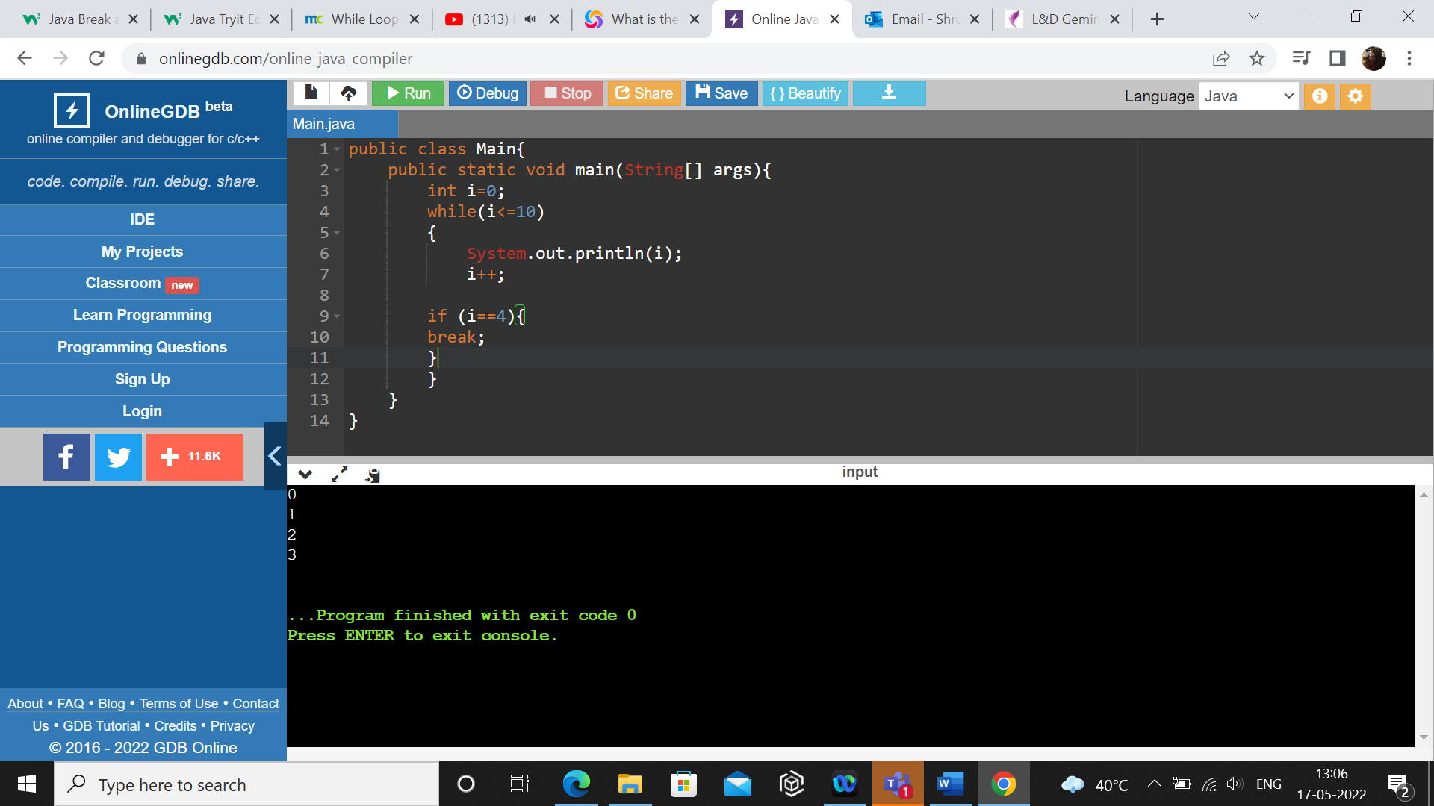

Continue statement :

Array:

Multi dimensional array

Methods:

Return statement

Operator overloading

Recursion Function calling itself or function calling function